Franklin COMP 294

Practicum Project Weekly Status Report

Name: Christa Fox

Course Number: COMP294-R1WW (F17)

Project Name: F17Gradebook

Week Number: 4

Progress for the week

* I completed 4 tickets for the presentation on Tuesday that our team leader presented. These were research activities and prototypes.
* This is the prototype for the log-in page that was created with Pencil, as suggested by our team leader—Lisa. 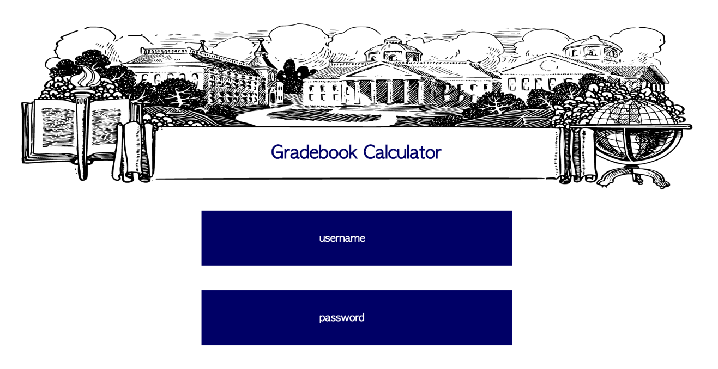
* The following is the prototype for the courses description. We wanted to include an editable field for grade, so that students could project possible grades. 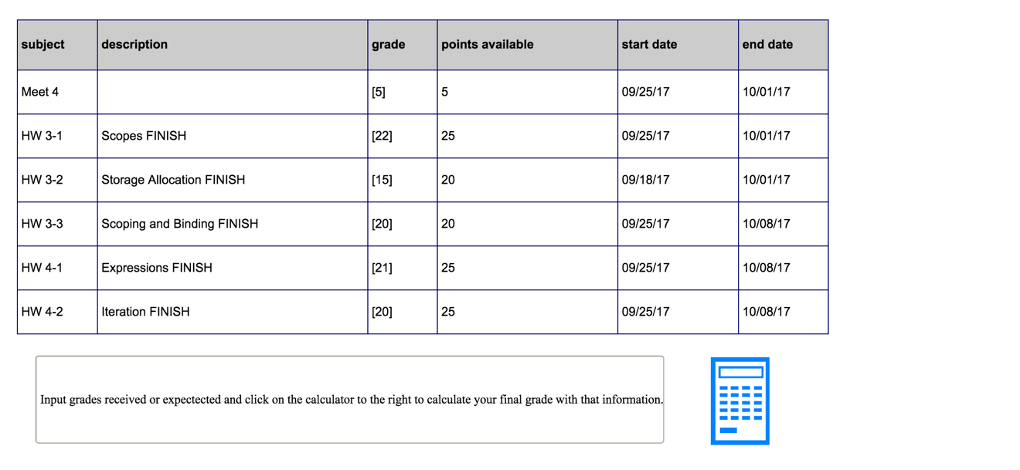
* I researched the possibility of using an import method to add due dates to a calendar, and to import class information into our app from myFranklin. What I found was a free software called Tabula that can be used on pc and mac. I downloaded the course PDF from myFranklin and converted this information to a CSV file.
* This is the original file and what it converted to
* ../Desktop/school%202017/comp%20294/comp215-v1ww-f17.pdf

Tasks For Week 1,,,,

Meet 1,1.5 hrs,5,"Mon, Sep 4","Sun, Sep 10"

Obtain a Test Proctor 1-1,-,-,"Mon, Sep 4","Sun, Sep 24"

Tasks For Week 2,,,,

Meet 2,1.5 hrs,5,"Mon, Sep 11","Sun, Sep 17"

HW 1-1: Programming Languages FINISH,3.0 hrs,25,"Mon, Sep 11","Sun, Sep 17"

Obtain a Test Proctor 1-1,-,-,"Mon, Sep 4","Sun, Sep 24"

Tasks For Week 3,,,,

Obtain a Test Proctor 1-1,-,-,"Mon, Sep 4","Sun, Sep 24"

Meet 3,1.5 hrs,5,"Mon, Sep 18","Sun, Sep 24"

HW 2-1: Grammar and Parse Trees FINISH,2.0 hrs,20,"Mon, Sep 18","Sun, Sep 24"

HW 2-2: Regular Expression FINISH,2.0 hrs,20,"Mon, Sep 18","Sun, Sep 24"

HW 3-2: Storage Allocation FINISH,1.0 hrs,20,"Mon, Sep 18","Sun, Oct 1"

Tasks For Week 4,,,,

Meet 4,1.5 hrs,5,"Mon, Sep 25","Sun, Oct 1"

HW 3-1: Scopes FINISH,2.0 hrs,25,"Mon, Sep 25","Sun, Oct 1"

HW 3-2: Storage Allocation FINISH,1.0 hrs,20,"Mon, Sep 18","Sun, Oct 1"

HW 3-3: Scoping and Binding FINISH,2.0 hrs,20,"Mon, Sep 25","Sun, Oct 1"

HW 4-1: Expressions FINISH,1.0 hrs,25,"Mon, Sep 25","Sun, Oct 8"

HW 4-2: Iteration FINISH,2.0 hrs,25,"Mon, Sep 25","Sun, Oct 8"

Tasks For Week 5,,,,

Meet 5,1.5 hrs,5,"Mon, Oct 2","Sun, Oct 8"

HW 4-1: Expressions FINISH,1.0 hrs,25,"Mon, Sep 25","Sun, Oct 8"

HW 4-2: Iteration FINISH,2.0 hrs,25,"Mon, Sep 25","Sun, Oct 8"

HW 5-2: Pointer Type_FINISH,2.0 hrs,20,"Mon, Oct 2","Sun, Oct 15"

HW 5-1: Type Equivalence_FINISH,2.0 hrs,20,"Mon, Oct 2","Sun, Oct 15"

Tasks For Week 6,,,,

Meet 6,1.5 hrs,5,"Mon, Oct 9","Sun, Oct 15"

HW 5-2: Pointer Type_FINISH,2.0 hrs,20,"Mon, Oct 2","Sun, Oct 15"

HW 5-1: Type Equivalence_FINISH,2.0 hrs,20,"Mon, Oct 2","Sun, Oct 15"

HW 6-2: Parameters_FINISH,2.0 hrs,20,"Mon, Oct 9","Sun, Oct 22"

HW 6-1: Stack Layout_FINISH,2.0 hrs,20,"Mon, Oct 9","Sun, Oct 22"

Tasks For Week 7,,,,

HW 6-2: Parameters_FINISH,2.0 hrs,20,"Mon, Oct 9","Sun, Oct 22"

HW 6-1: Stack Layout_FINISH,2.0 hrs,20,"Mon, Oct 9","Sun, Oct 22"

Meet 7,1.5 hrs,5,"Mon, Oct 16","Sun, Oct 22"

Midterm Exam,1.5 hrs,220,"Mon, Oct 16","Mon, Oct 23"

Tasks For Week 8,,,,

Midterm Exam,1.5 hrs,220,"Mon, Oct 16","Mon, Oct 23"

Meet 8,1.5 hrs,5,"Mon, Oct 23","Sun, Oct 29"

HW 8-2: Discussion Assignment,2.0 hrs,10,"Mon, Oct 23","Sun, Oct 29"

HW 8-1: C Programming I FINISH,4.0 hrs,40,"Mon, Oct 23","Sun, Nov 5"

Tasks For Week 9,,,,

Meet 9,1.5 hrs,5,"Mon, Oct 30","Sun, Nov 5"

HW 8-1: C Programming I FINISH,4.0 hrs,40,"Mon, Oct 23","Sun, Nov 5"

HW 9-1: C Programming II FINISH,-,40,"Mon, Oct 30","Sun, Nov 12"

Tasks For Week 10,,,,

Meet 10,1.5 hrs,5,"Mon, Nov 6","Sun, Nov 12"

HW 9-1: C Programming II FINISH,-,40,"Mon, Oct 30","Sun, Nov 12"

HW 10-1: C Programming Project FINISH,4.0 hrs,60,"Mon, Nov 6","Sun, Nov 26"

Tasks For Week 11,,,,

Meet 11,1.5 hrs,5,"Mon, Nov 13","Sun, Nov 19"

HW 11-1: Scheme Programming FINISH,3.0 hrs,40,"Mon, Nov 13","Sun, Nov 26"

HW 10-1: C Programming Project FINISH,4.0 hrs,60,"Mon, Nov 6","Sun, Nov 26"

ek 12,,,,

Meet 12,1.5 hrs,5,"Mon, Nov 20","Sun, Nov 26"

HW 11-1: Scheme Programming FINISH,3.0 hrs,40,"Mon, Nov 13","Sun, Nov 26"

HW 10-1: C Programming Project FINISH,4.0 hrs,60,"Mon, Nov 6","Sun, Nov 26"

ek 13,,,,

Meet 13,1.5 hrs,5,"Mon, Nov 27","Sun, Dec 3"

HW 13-1: Prolog Programming FINISH,3.0 hrs,40,"Mon, Nov 27","Sat, Dec 9"

ek 14,,,,

HW 13-1: Prolog Programming FINISH,3.0 hrs,40,"Mon, Nov 27","Sat, Dec 9"

Meet 14,1.5 hrs,5,"Mon, Dec 4","Sun, Dec 10"

ek 15,,,,

Final Exam,1.5 hrs,220,"Mon, Dec 11","Sat, Dec 16"

I then looked at the description of the calendar imports and found that google will only understand certain headers. Using these headers I was able to import to calendar subject,description,start date,end date

Meet 4,5,09/25/17,10/01/17

HW 3-1: Scopes FINISH,25,09/25/17,10/01/17

HW 3-2: Storage Allocation FINISH,20,09/18/17,10/01/17

HW 3-3: Scoping and Binding FINISH,20,09/25/17,10/08/17

HW 4-1: Expressions FINISH,25,09/25/17,10/08/17

HW 4-2: Iteration FINISH,25,09/25/17,10/08/17

* 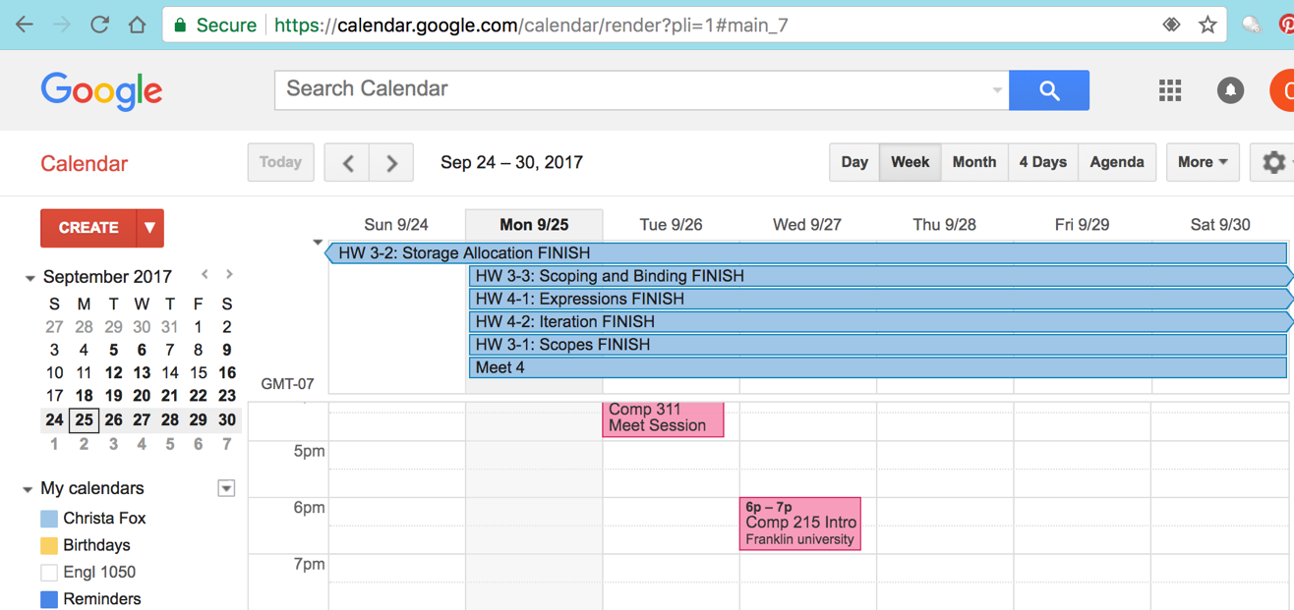
* I realized after that I should only list due date, and not the start date.
* There is quite a bit of cleaning needed to use the import feature in this way, but it still might be easier than user input for all of the fields.

Problems Solved

* Android developer is loaded, updated, and the assignment has been pulled from the repository.
* We defined the scopes of the assignment by listing what was the bare minimum and what were our next steps if we finish early.

Communication

* Closed 4 tickets.
* Accepted 4 tickets
* Pulled from the repository
* Uploaded documents to the notebooks.
* Used text, email, and unfuddle for communication.

Goals for next week

* We will work on layouts and the parameters for the database this week.
* During our meet, I received assistance on setting up the git repository in my android developer.
* I don’t forsee any complications.